**Course name: Human Computer Interaction**

**Assignment no.: 3**

**Title:**

**Subtopic 1. Core values?**

In the Healthcare & Safety videos, the interactive technologies showcased provide various values to people in the medical and safety domains. Some of the important values include effective communication, timely and accurate information, reliability, speed, and accessibility to necessary data. These values can contribute to making people healthy and safe by ensuring that they have access to the right information at the right time, are able to communicate effectively with medical professionals and receive fast and reliable care. In designing HCI applications for healthcare and safety, it is crucial to consider these values to ensure that people receive the best possible care and support.

First, in medical and healthcare service, Effective communication between doctors and patients is made possible by screens and other interfaces that allow them to communicate more effectively than ever before. Timely and accurate information is important for patients to be informed and make decisions about their health. It can also reduce medical errors. For example, medical information about patients is shared by all hospitals. This ensures that risky surgeries or medications are not prescribed for past illnesses, and that accurate diagnoses are made. Reliability is the most important factor for patients. Patients trust their doctors more when they know that machines don't make mistakes. As we advance, more and more tasks in surgery are performed by machines rather than humans. Humans get tired and make mistakes, but robots don't. If you look at the time it takes to diagnose a disease or do a surgery, it's been reduced by using machines. In the past, without robots and machines, we had to go through a long series of tests that took a long time to accurately diagnose the disease, but nowadays, the tests are done with machines. The same goes for surgery time.

Interactive technologies that help keep people safe have become increasingly prevalent in recent years. One of the most significant benefits of these technologies is enhanced situational awareness, which can help people anticipate and respond to potential hazards more effectively. For instance, smart sensors and alarms can detect potential dangers and alert people in real-time, allowing them to take prompt and appropriate action to mitigate risks. Effective communication is another crucial value that can be delivered through such technologies. With the help of interactive technologies, people can coordinate and collaborate to manage and mitigate risks effectively. For example, emergency responders can use radios and other communication devices to communicate with each other during rescue operations. Moreover, interactive technologies can provide people with the right information at the right time, be accurate and reliable, and work fast enough to keep them safe. Advanced sensors and alarms can detect potential dangers and alert people in real-time, allowing them to take prompt and appropriate action. Fast enough response times are also essential, as even slight delays can increase the risk of harm. Finally, easy access to important information like weather forecasts, traffic updates, or incident reports can help people better prepare for and avoid potentially dangerous situations. For instance, weather alerts can notify people of approaching storms, allowing them to take shelter and stay safe.

In conclusion, interactive technologies in healthcare and safety domains have significant values that can make people healthier and safer. Effective communication, timely and accurate information, reliability, speed, and accessibility to necessary data are some of the critical values that such technologies offer. It is essential to consider these values when designing HCI applications for healthcare and safety to ensure that people receive the best possible care and support. With the help of these technologies, people can be more aware of dangers, communicate better, and make informed decisions to stay safe.

**Subtopic 2. HCI ideas?**

|  |  |  |
| --- | --- | --- |
| [A] What issues? | [B] Your idea to satisfy their needs | [C] Detailed INTERACTION methods |
| Easy access to a doctor | Using VR and pad to meet doctor for diagnosis | To meet the doctor book the schedule in online. Wear the VR glass and headset with some pad if it is necessary and start to meet. |
| Accurate medical diagnosis | AI assist the doctor to make accurate medical diagnosis | The doctor enters the details into a computer and the AI makes a diagnosis together with doctor. |
| Healthcare food service | Healthy food recommendations from the chips in your body | It identifies the nutrients you're lacking from the chips in your body and gives you meal recommendations that you can make with what's in your refrigerator. |

[D] Idea Sketch

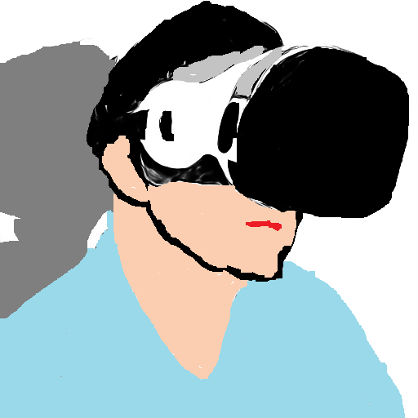VR to meet with doctor